**ReactJS Hands-on**

**1)Cricket Application with ES6 Features:**

import React from 'react';

function ListofPlayers() {

const players = [

{ name: 'Virat Kohli', score: 120 },

{ name: 'Rohit Sharma', score: 95 },

{ name: 'KL Rahul', score: 65 },

{ name: 'Shreyas Iyer', score: 40 },

{ name: 'Hardik Pandya', score: 80 },

{ name: 'Ravindra Jadeja', score: 75 },

{ name: 'Jasprit Bumrah', score: 15 },

{ name: 'Mohammed Shami', score: 10 },

{ name: 'Kuldeep Yadav', score: 5 },

{ name: 'Yuzvendra Chahal', score: 20 },

{ name: 'Rishabh Pant', score: 110 }

];

const allPlayersList = players.map((player, index) => (

<li key={index}>{player.name} - Score: {player.score}</li>

));

const playersBelow70 = players.filter(player => player.score < 70);

const playersBelow70List = playersBelow70.map((player, index) => (

<li key={index}>{player.name} - Score: {player.score}</li>

));

return (

<div style={{ padding: '20px', border: '1px solid #ccc', margin: '15px', borderRadius: '8px', boxShadow: '0 2px 4px rgba(0,0,0,0.1)' }}>

<h2>All Players & Scores</h2>

<ul>{allPlayersList}</ul>

<h2>Players with Scores Below 70 (Filtered using Arrow Functions)</h2>

{playersBelow70.length > 0 ? (

<ul>{playersBelow70List}</ul>

) : (

<p>No players found with scores below 70.</p>

)}

</div>

);

}

export default ListofPlayers;

Create the IndianPlayers.js Component

import React from 'react';

function IndianPlayers() {

const indianCricketTeam = [

"Rohit Sharma (C)", "KL Rahul (WK)", "Shubman Gill", "Virat Kohli",

"Shreyas Iyer", "Hardik Pandya", "Ravindra Jadeja", "Mohammed Shami",

"Jasprit Bumrah", "Kuldeep Yadav", "Mohammed Siraj"

];

const [oddPlayer1, , oddPlayer2, , oddPlayer3, , oddPlayer4, , oddPlayer5, , oddPlayer6] = indianCricketTeam;

const [, evenPlayer1, , evenPlayer2, , evenPlayer3, , evenPlayer4, , evenPlayer5] = indianCricketTeam;

const t20Players = ["Suryakumar Yadav", "Rinku Singh", "Jitesh Sharma"];

const ranjiTrophyPlayers = ["Hanuma Vihari", "Sarfaraz Khan", "Priyank Panchal"];

const mergedPlayers = [...t20Players, ...ranjiTrophyPlayers];

return (

<div style={{ padding: '20px', border: '1px solid #ccc', margin: '15px', borderRadius: '8px', boxShadow: '0 2px 4px rgba(0,0,0,0.1)' }}>

<h2>Indian Team (Destructuring Example)</h2>

<h3>Odd Team Players:</h3>

<ul>

<li>{oddPlayer1}</li>

<li>{oddPlayer2}</li>

<li>{oddPlayer3}</li>

<li>{oddPlayer4}</li>

<li>{oddPlayer5}</li>

<li>{oddPlayer6}</li>

</ul>

<h3>Even Team Players:</h3>

<ul>

<li>{evenPlayer1}</li>

<li>{evenPlayer2}</li>

<li>{evenPlayer3}</li>

<li>{evenPlayer4}</li>

<li>{evenPlayer5}</li>

</ul>

<h2>Merged Players (T20 & Ranji Trophy)</h2>

<ul>

{mergedPlayers.map((player, index) => (

<li key={index}>{player}</li>

))}

</ul>

</div>

);

}

export default IndianPlayers; Modify App.js to Conditionally Render Components

import React from 'react';

import './App.css';

import ListofPlayers from './ListofPlayers';

import IndianPlayers from './IndianPlayers';

function App() {

const displayListofPlayers = true;

return (

<div className="App" style={{ textAlign: 'center', fontFamily: 'Arial, sans-serif' }}>

<h1>Cricket App</h1>

{displayListofPlayers ? (

<ListofPlayers />

) : (

<IndianPlayers />

)}

</div>

);

}

export default App; Run the React Application npm start OUTPUT:

**Output**

Cricket App

· All Players & Scores

· * Virat Kohli - Score: 120

· * Rohit Sharma - Score: 95

· * KL Rahul - Score: 65

· * Shreyas Iyer - Score: 40

· * Hardik Pandya - Score: 80

· * Ravindra Jadeja - Score: 75

· * Jasprit Bumrah - Score: 15

· * Mohammed Shami - Score: 10

· * Kuldeep Yadav - Score: 5

· * Yuzvendra Chahal - Score: 20

· * Rishabh Pant - Score: 110

· Players with Scores Below 70 (Filtered using Arrow Functions)

· * KL Rahul - Score: 65

· * Shreyas Iyer - Score: 40

· * Jasprit Bumrah - Score: 15

· * Mohammed Shami - Score: 10

· * Kuldeep Yadav - Score: 5

· * Yuzvendra Chahal - Score: 20

·

**2)Create an “Officespacerentalapp”:**

Replace App.js Code import React from 'react';

import './App.css';

function App() {

const offices = [

{

name: "GreenSpace Tower",

rent: 55000,

address: "MG Road, Bangalore",

image: "https://via.placeholder.com/300x200?text=Office+1"

},

{

name: "Skyline Hub",

rent: 75000,

address: "Hitech City, Hyderabad",

image: "https://via.placeholder.com/300x200?text=Office+2"

},

{

name: "WorkNest",

rent: 60000,

address: "Sector 44, Gurgaon",

image: "https://via.placeholder.com/300x200?text=Office+3"

}

];

return (

<div className="App">

<h1>🏢 Office Space Rental Listings</h1>

{offices.map((office, index) => (

<div key={index} style={{ border: "1px solid gray", margin: "10px", padding: "10px", width: "320px" }}>

<img src={office.image} alt={office.name} style={{ width: "100%", height: "200px" }} />

<h2>{office.name}</h2>

<p><strong>Address:</strong> {office.address}</p>

<p style={{ color: office.rent < 60000 ? "red" : "green" }}>

<strong>Rent:</strong> ₹{office.rent}

</p>

</div>

))}

</div>

);

}

export default App;

App.css Styling .App {

text-align: center;

font-family: Arial, sans-serif;

padding: 20px;

background-color: #f0f8ff;

}

**OUTPUT**

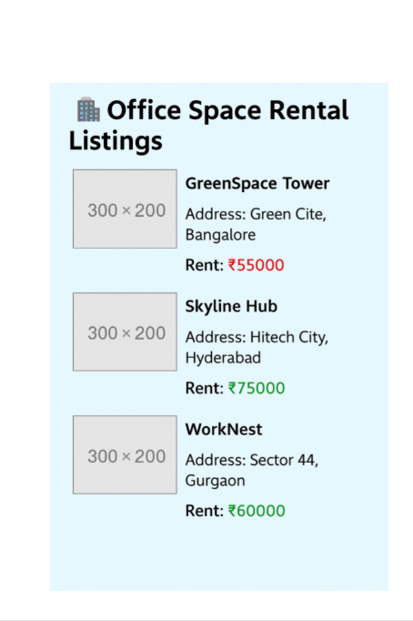

**3)Create an "eventexamplesapp" :**

npm start

App.js Code import React, { useState } from 'react';

import './App.css';

function App() {

const [count, setCount] = useState(0);

const [message, setMessage] = useState('');

const [euro, setEuro] = useState('');

const [rupees, setRupees] = useState('');

const increment = () => {

setCount(count + 1);

sayHello();

};

const decrement = () => {

setCount(count - 1);

};

const sayHello = () => {

setMessage('Hello! You clicked Increment!');

};

const sayWelcome = (text) => {

setMessage(text);

};

const handleClick = (event) => {

alert('I was clicked');

};

const handleEuroChange = (e) => {

setEuro(e.target.value);

};

const handleSubmit = () => {

const rupeeValue = parseFloat(euro) * 90; // Assuming 1 Euro = 90 INR

setRupees(rupeeValue.toFixed(2));

};

return (

<div className="App">

<h1>React Event Handling Demo</h1>

<h2>Counter: {count}</h2>

<button onClick={increment}>Increment</button>

<button onClick={decrement}>Decrement</button>

<p>{message}</p>

<button onClick={() => sayWelcome('Welcome to React Event Handling!')}>Say Welcome</button>

<button onClick={handleClick}>Click me (Synthetic Event)</button>

<hr />

<h2>Currency Converter (Euro to INR)</h2>

<input type="number" placeholder="Enter Euro" value={euro} onChange={handleEuroChange} />

<button onClick={handleSubmit}>Convert</button>

{rupees && <p>In INR: ₹{rupees}</p>}

</div>

);

}

export default App;

**OUTPUT**

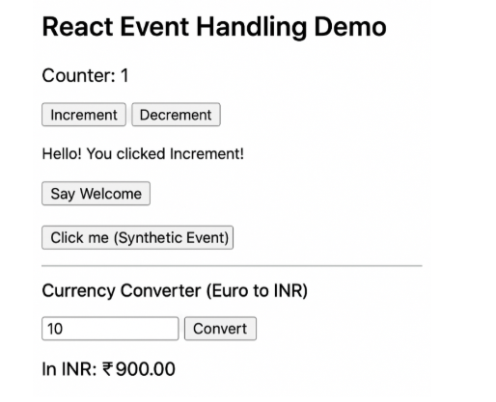

**4)Create a "ticketbookingapp"** :

App.js

import React, { useState } from 'react';

import GuestPage from './GuestPage';

import UserPage from './UserPage';

function App() {

const [isLoggedIn, setIsLoggedIn] = useState(false);

const handleLogin = () => setIsLoggedIn(true);

const handleLogout = () => setIsLoggedIn(false);

return (

<div style={{ textAlign: 'center', marginTop: '50px' }}>

<h1>Flight Ticket Booking App</h1>

{

isLoggedIn ? (

<>

<UserPage />

<button onClick={handleLogout}>Logout</button>

</>

) : (

<>

<GuestPage />

<button onClick={handleLogin}>Login</button>

</>

)

}

</div>

);

}

export default App;

GuestPage.js import React from 'react';

function GuestPage() {

return (

<div>

<h2>Welcome, Guest!</h2>

<p>You can view available flights, but please login to book tickets.</p>

<ul>

<li> Flight A123 - Hyderabad to Bangalore</li>

<li> Flight B456 - Chennai to Mumbai</li>

</ul>

</div>

);

}

export default GuestPage;

UserPage.js import React from 'react';

function UserPage() {

return (

<div>

<h2>Welcome, User!</h2>

<p>You are logged in. You can now book tickets.</p>

<button>Book Flight A123</button>

<button>Book Flight B456</button>

</div>

);

}

export default UserPage;

**OUTPUT**

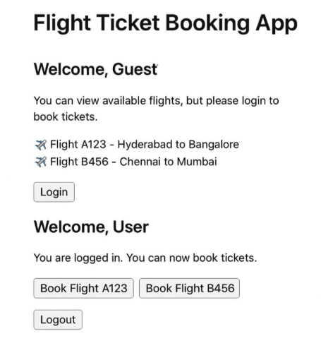

**5)Create a “bloggerapp”:**

3 components:

· BookDetails

· BlogDetails

· CourseDetails

Implement conditional rendering using as many ways as possible

BookDetails.js import React from 'react';

function BookDetails() {

return (

<div>

<h2>Book Details</h2>

<p>Title: React Simplified</p>

<p>Author: Dan Abramov</p>

</div>

);

}: BlogDetails.js

import React from 'react';

function BlogDetails() {

return (

<div>

<h2>Blog Details</h2>

<p>Title: Understanding JSX</p>

<p>Author: Sophie Alpert</p>

</div>

);

}

export default BlogDetails; CourseDetails.js import React from 'react';

function CourseDetails() {

return (

<div>

<h2>Course Details</h2>

<p>Course: Full Stack Development</p>

<p>Platform: Coursera</p>

</div>

);

}

export default CourseDetails; App.js with multiple types of conditional rendering

import React, { useState } from 'react';

import BookDetails from './components/BookDetails';

import BlogDetails from './components/BlogDetails';

import CourseDetails from './components/CourseDetails';

function App() {

const [activeComponent, setActiveComponent] = useState("book");

const showComponent = () => {

switch (activeComponent) {

case "book":

return <BookDetails />;

case "blog":

return <BlogDetails />;

case "course":

return <CourseDetails />;

default:

return <h2>No Component Selected</h2>;

}

};

const shouldShowCourse = true; // for logical && example

return (

<div style={{ padding: '20px' }}>

<h1>BloggerApp - Conditional Rendering</h1>

<button onClick={() => setActiveComponent("book")}>Show Book</button>

<button onClick={() => setActiveComponent("blog")}>Show Blog</button>

<button onClick={() => setActiveComponent("course")}>Show Course</button>

<hr />

{/* 1. Using switch-case */}

{showComponent()}

{/* 2. Using ternary operator */}

<div>

<h3>Using Ternary Operator:</h3>

{activeComponent === "book" ? <BookDetails /> : <p>Not Book Details</p>}

</div>

{/* 3. Using && operator */}

<div>

<h3>Using Logical &&:</h3>

{shouldShowCourse && <CourseDetails />}

</div>

{/* 4. Using if-else in code block */}

<div>

<h3>Using If-Else:</h3>

{

(() => {

if (activeComponent === "blog") return <BlogDetails />;

else return <p>No Blog Selected</p>;

})()

}

</div>

</div>

);

}

export default App;

**OUTPUT**

